Articulo

Design of a chatbot application to improve stress and self-esteem in IE students José Buenaventura Sepúlveda, cañete 2024

Jainer Quispe-Madueño1 and Alex Pacheco1*

|  |
| --- |
|  |

**Abstract:** This study addresses the modernization of stress management and self-esteem in students, using artificial intelligence to overcome the challenges of traditional methods. In this context, the objective of the research is to design and implement a chatbot based on artificial intelligence to improve stress management and self-esteem in the students of the IE José Buenaventura Sepúl-veda, Cañete 2024. The development began with planning , defining user stories and their priority; The design was created using a simple model with wireframes and class diagrams; During coding, pair programming with incremental implementation was highlighted; In the testing phase, automatic and manual integration tests were carried out, documented through acceptance tests to ensure the quality of the developed software. From the perspective of educational management, there was a significant increase in the well-being of the students. This implies a better allocation and use of the emotional and academic resources available in the institution. Likewise, the decrease in the incidence of stress suggests greater precision in emotional and academic support, which translates into safer and more effective care for students. This work contributes to the advancement of more inclusive and efficient educational environments for the management of student well-being. Strengthens the capacity for planning, participatory, integrated and sustainable management in education.

**Keywords:** Chatbots; artificial intelligence; stress management; self-esteem; education; student welfare.

1. Introduction

Virtual assistants or chatbots, designed to simulate human conversations through automatic responses, are transforming the way companies connect with their customers (Salvat et al., 2020). The implementation of a chatbots re-presents a powerful tool that can guide users through the entire process, from the initial consultation to the completion of the consultation (Guerrero, 2018). Chatbots in mobile applications facilitate immediate and continuous access to services and support, allowing users to make queries, obtain recommendations, carry out transactions and operations from their mobile devices (Pedro et al., 2018).

Chatbots in the educational environment provide a constant and personalized communication channel that not only allows students to access academic but also emotional support, providing stress management techniques and motivational messages (Ipanaque & Torres, 2023).

Despite the advances, there are considerable gaps in this technology. It is true that chatbots have the capacity to offer information and support adapted to individual needs, but they have not yet reached their maximum potential in this aspect, especially in a health environment.

In the current educational environment, the ability of institutions to provide effective emotional and academic support to students is fundamental to their success (Falcon et al., 2022). However, many schools and universities face significant challenges, in this case being stress management and improving students' self-esteem (Chieng & Medina, 2020). Often, these institutions lack the technological resources necessary to implement effective solutions, as in the case of having a chabots integrated into their educational system (Quispe et al., 2018).

The implementation of a chatbot application in an educational institution will have a positive impact on stress management and strengthening self-esteem in students. By providing immediate and personalized access to emotional and academic support tools, as well as real-time assistance at all times, an overall improvement in student well-being and academic performance is expected.

The main objective of this work is to design a chatbot application in the educational environment that can fully manage the emotional and academic support of students, providing stress management techniques, motivational messages and real-time assistance at all times. This chatbot will be designed to address identified gaps in current technology, ensuring effective personalization of care and a positive impact on student well-being.

The contribution of this application is to significantly improve students' stress management and self-esteem, critical aspects for their academic success and general well-being. In addition to being an effective robust technological tool, it also seeks to fill gaps identified in previous studies on the effectiveness and adaptation of psychoeducational support technologies in the educational context, thus contributing to technological innovation in the educational field and offering a replicable model for other institutions with similar challenges.

1. Materials and Methods
   1. *Materials*

For this research, high-performance hardware was required, opting to use an ASUS TUF Gaming A15 laptop, model FA506QM_FA506QM. This computer has an AMD Ryzen 7 5800H processor with Radeon graphics, which offers a base frequency of 3201 MHz and up to 8 main cores, providing robust and efficient processing capacity. Additionally, the system includes 16GB of DDR4 RAM and a solid storage of 1TB SSD M.2 2280 PCIe Gen4x4 NVMe. The laptop operates under the Windows 11 Home operating system, offering an optimized and secure user interface for project development.

* 1. *Agile development methodology (XP)*

The XP methodology is an agile software development approach that focuses on improving software quality to customer needs. In this sense of a chatbot application aimed at improving stress and self-esteem in students, this methodology facilitates close collaboration with interested parties to clearly define the requirements and functionalities of the chatbot. In this sense, it allows us to adapt and perfect the chatbot in short development cycles, ensuring that the final product is highly effective and aligned with the emotional and psychological needs of the students. Figure 1.

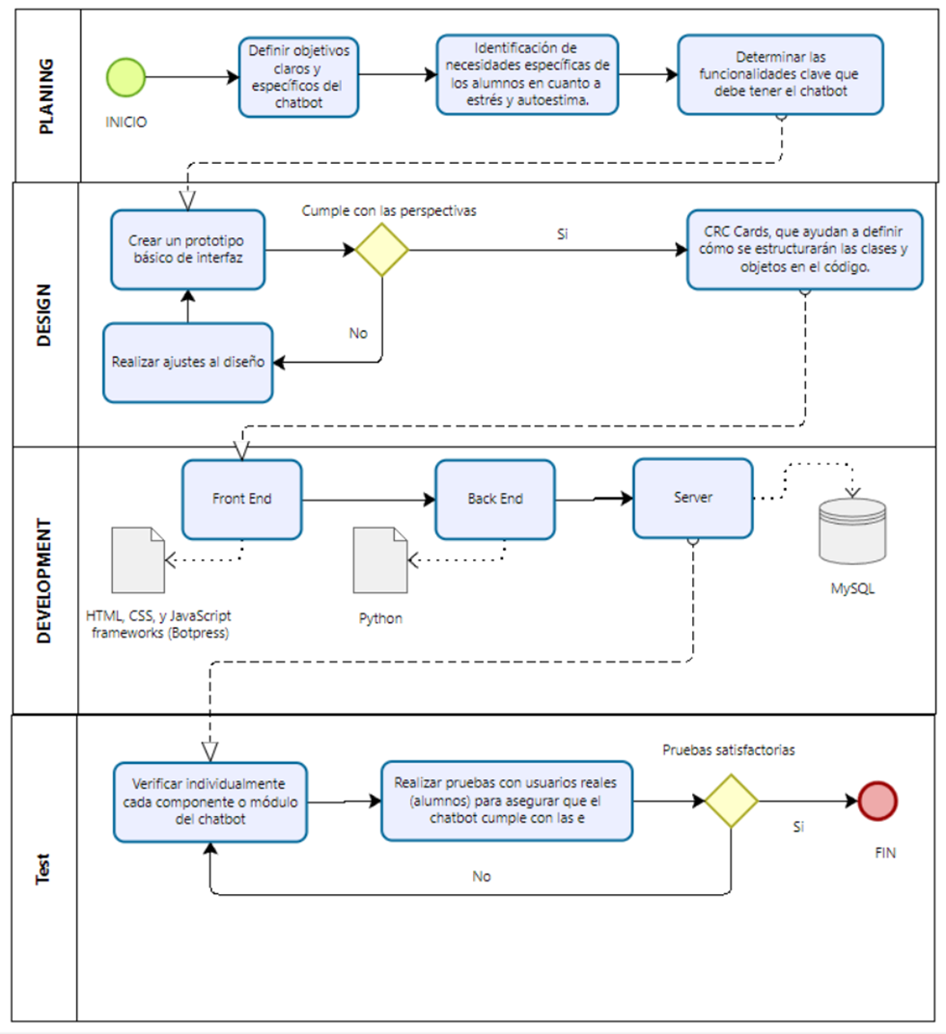

**Figure 1:** Flowchart with the XP methodology, own elaboration

* + 1. *Planning phase:*

An initial meeting is held with stakeholders to understand the specific needs of the students related to stress and self-esteem. During this phase, user stories are identified and detailed, describing situations in which students might need the chatbot's assistance. The technical and functional requirements of the chatbot are also established, selecting the platforms and tools necessary for its development and implementation.

* + 1. *Design phase:*

It focuses on creating wireframes for the chatbot interface, ensuring it is friendly and accessible to users. Additionally, the system architecture is defined, including how the chatbot will integrate with existing databases and other institutional systems. A rapid prototype is developed and subjected to review to allow improvements based on initial feedback. Figure 2.

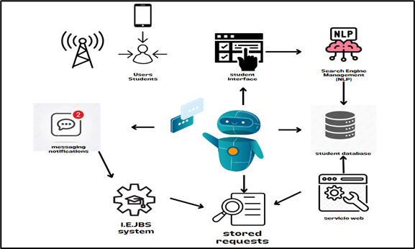

**Figure 2:** Architecture of the chatbot application, own elaboration.

* + 1. *Development phase:*

HTML, CSS and JavaScript are used to develop the user interface, while the chatbot logic is implemented using Python, with frameworks such as ChatterBot or Rasa for natural language processing. Database integration is handled with MySQL, and integration testing is performed to ensure that all components work together effectively.

* + 1. *Test phase:*

Unit tests are carried out to verify each chatbot module individually, ensuring its correct functioning in isolation. User acceptance testing involves sessions with students to evaluate the usability and effectiveness of the chatbot in real conditions. The feedback obtained during these tests is crucial to make continuous adjustments and improvements, ensuring that the chatbot effectively meets the needs of the students and improves both their stress and self-esteem.

1. Results
   1. Presentation of the first interface, login.

Accessibility

The ability to log in or register using Google or Facebook accounts simplifies the login process, which can increase student engagement by making it easier for them to log into the system.

Increased user registration

This ease of access can result in a greater number of registrations and, therefore, an increase in the number of students who can benefit from the stress management and self-esteem tools provided by chatbots.

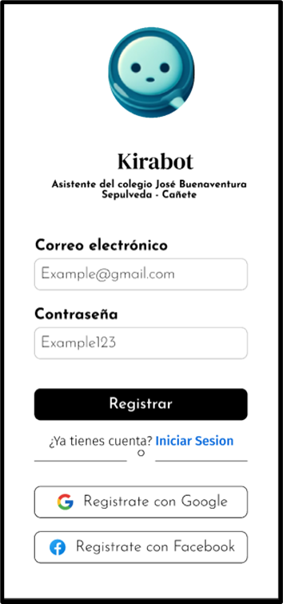

**Figure *3*:** Student Login Interface

* 1. Messaging interaction interface.

Custom interaction:

The chatbot is designed to respond to specific queries from students, which can lead to better stress management and strengthening self-esteem by offering emotional support tailored to individual needs.

Continuous and real-time support:

The chatbot's ability to interact in real time ensures that students receive immediate assistance, which is crucial for effective management of stress and situations requiring urgent emotional support.

Improving Student Wellbeing:

With continued use, the chatbot is expected to help improve students' overall well-being and academic performance by providing strategies and support for stress management and improving self-esteem.

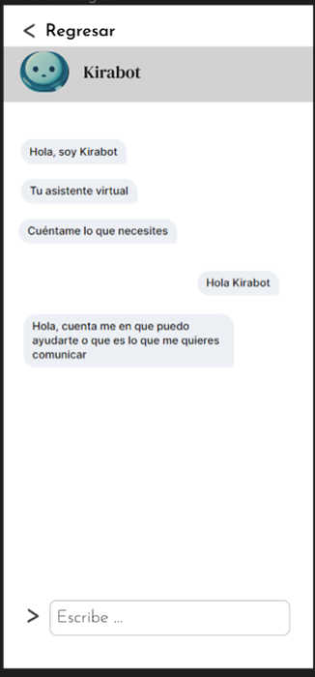

**Figure 4**: Interaction and messaging interface.

1. Discussion

As educational institutions seek to improve the emotional and academic well-being of students, they face crucial challenges in managing resources and implementing effective solutions. In this context, artificial intelligence (AI) emerges as a key factor to address these challenges and to create more efficient and intelligent educational environments (Garcia-Retuerta et al., 2021).

The implementation of an educational chatbot, as presented in this study, not only has a positive impact on the efficiency of student service, but also improves strategic decision making and raises the quality of educational services in the context of management. smart schoolboy. This control instrument provides a holistic view of critical information, streamlining the deep and rapid understanding of the data, which enables the analyzes to have a considerable impact on the general functioning of the educational environment. This approach moves beyond the academic field and finds relevant applications in the educational environment in general. Just as the chatbot contributes to obtaining results by monitoring student attention, it also facilitates strategic decision-making in the management of educational resources and allows the identification of risks, while promoting improvements in the productivity. These elements stand as crucial pillars to ensure the competitiveness and sustainability of an educational institution (Yang et al., 2023). The effectiveness of this approach is evident in the optimization of processes and the making of informed decisions, highlighting its importance in improving educational management.

1. Limitations and future work

This research does not address certain criteria of artificial intelligence for its implementation in a virtual educational management platform. Among the limitations identified, those related to privacy and data security in the management of sensitive information stand out, as well as the restriction on integration with other existing educational systems. There is resistance and lack of understanding on the part of education professionals towards the adoption of AI technologies.

For future work in the field of artificial intelligence in educational systems, the implementation of end-to-end encryption algorithms and the adoption of country-specific data security policies is suggested. In addition, the adoption of interoperability standards is proposed to facilitate the electronic exchange of educational data. Users should also be involved from the initial stages, provide continuous training to minimize resistance to change and enhance the system to interpret visual information, thus improving the ability to diagnose and support students.

1. Conclusions

The implementation of the chatbot at IE José Buenaventura Sepúlveda has significantly transformed the stress management and self-esteem of students. Before its introduction, students faced great challenges due to the lack of technological resources and constant emotional support, which negatively affected their well-being and academic performance. With the chatbot, a great improvement has been seen in these aspects. Their accessibility and ability to offer ongoing, personalized support have reduced stress and increased students' self-esteem. This has improved the quality of educational service and resource management, demonstrating that integrating advanced technology is key to improving the educational experience and well-being of students.

References

Chieng Cueva, A. I., & Medina Aguirre, G. E. (2020). Evaluation of mental disorders of anxiety and depression via Chatbot. Institutional Repository - Ulima. https://repositorio.ulima.edu.pe/handle/20.500.12724/13253

Falcon, N., Alonso, J., Ing Carranza Barrena, M., Eduardo, W., Investigation, L. DE, Quispe, B., & Javier, C. (2022). Mobile application integrated with chatbot for booking medical appointments at the Podoyimfeet podiatry center. Institutional Repository - UCV. https://repositorio.ucv.edu.pe/handle/20.500.12692/112354

Guerrero Carrazco, J. K. (2018). Chatbot for sales in the company Eximport Distribuidores del Perú S.A.C, Lima 2018. César Vallejo University. https://repositorio.ucv.edu.pe/handle/20.500.12692/21690

Ipanaque Maza, A. M., & Torres Colan, K. A. (2023). Development of a psychoeducational mobile application integrating chatbots for the management of anxiety and depression in adolescents. Institutional Repository - UCV. https://repositorio.ucv.edu.pe/handle/20.500.12692/134033

Pedro, D., Gonzales, A., Asesor, C., Renee, M. G., & Crisostomo, R. (2018). Mobile application with Chatbot for learning to use the Canvas platform for UTP teachers. César Vallejo University. https://repositorio.ucv.edu.pe/handle/20.500.12692/30232

Salvat, B. G., Roig, A. E., & Sánchez, M. P. (2020). Co-design of a chatbot to facilitate administrative procedures for migrants. Pixel-Bit, Journal of Media and Education, 57, 91–106. https://doi.org/10.12795/PIXELBIT.2020.I57.03

Systems, by, Sánchez Chávez Erick Joán, B., Del Aguila Quispe Jhordy Alexi Approved by, B., Romel Alcántara Moreno PRESIDENT, Ó., José Luis Romero Ruiz SECRETARY, H., & Francisco Pacheco Torres, J. ( 2018). Mobile Application Based on Chatbot to Improve the Dissemination of Information on Urban Transportation Routes in the Provincial Municipality of Trujillo, 2018. César Vallejo University. https://repositorio.ucv.edu.pe/handle/20.500.12692/32126